Weighing scale
# Source: AI Source: Provided by: [Data Path: Persons Table -> ID Column: 1, Name_En Column: Motasem Essam] -> From: [ChatGPT] on [7/17/2026]
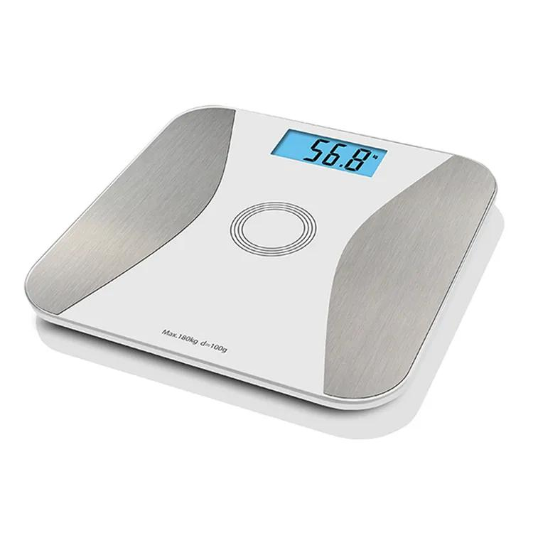
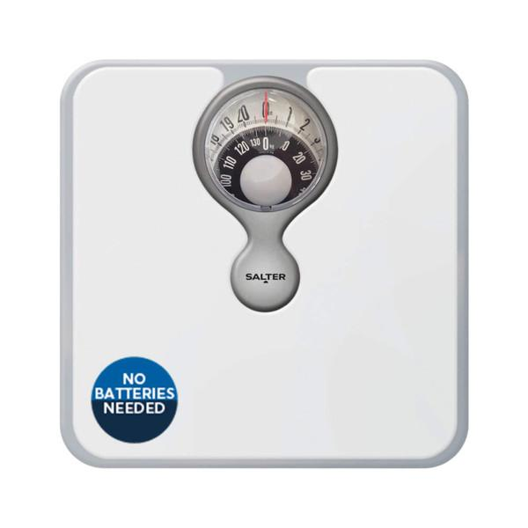
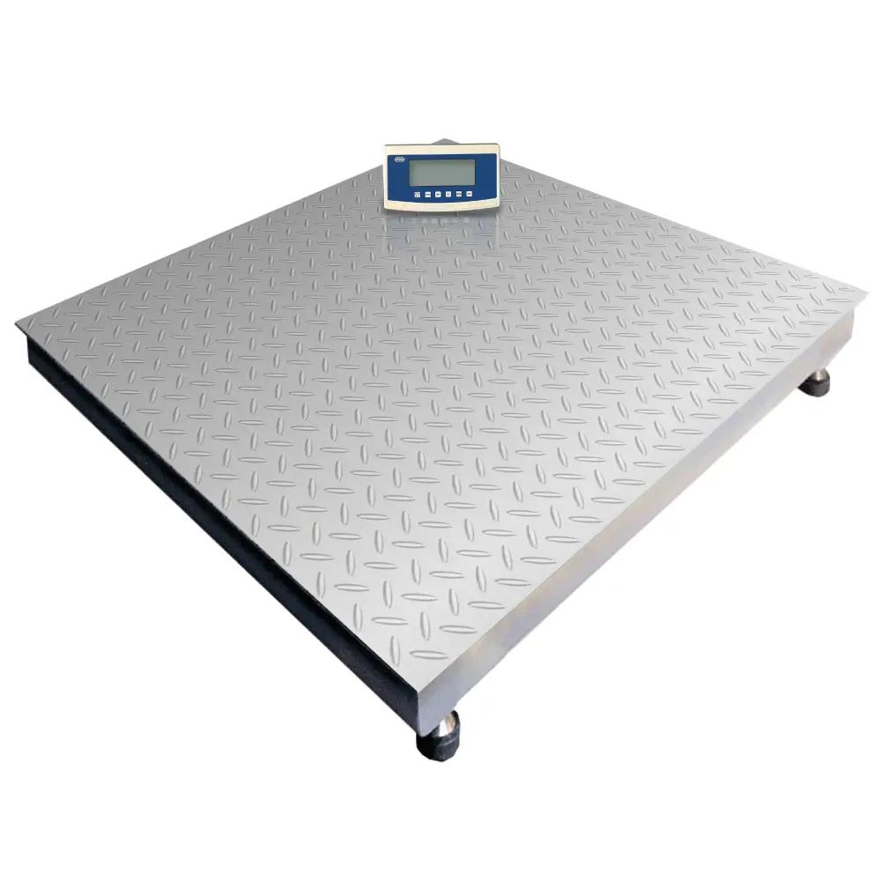
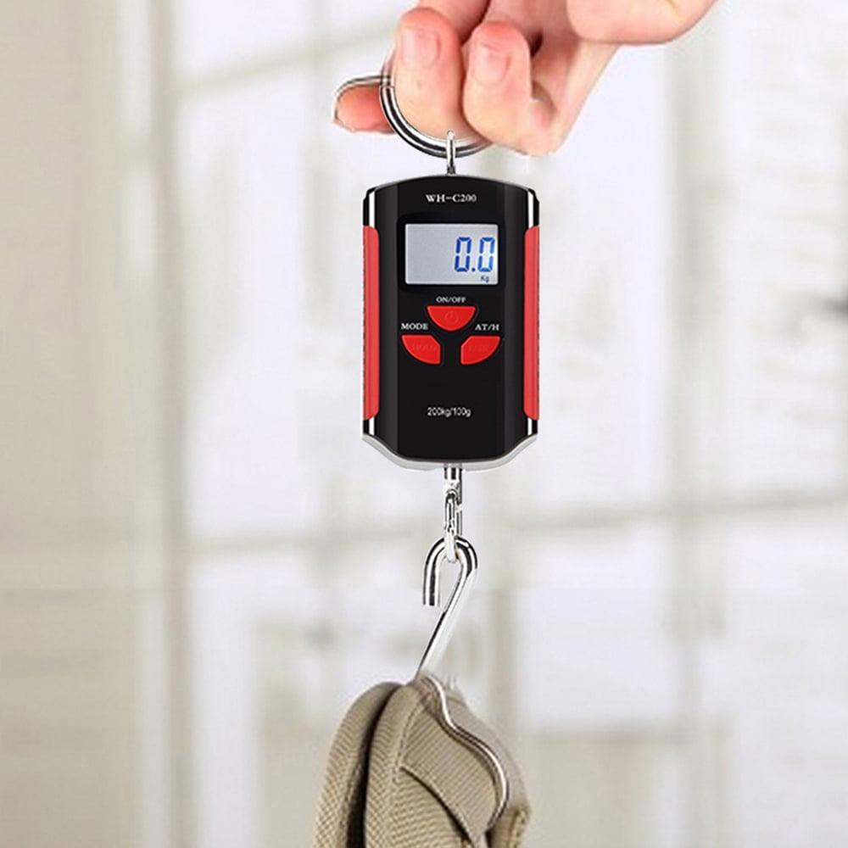
A Weighing Scale is a measuring instrument used to determine the weight of an object. Modern electronic weighing scales often display values in units of mass (kg, g, lb) after calibration under Earth's gravity, although the sensing mechanism actually measures the force (weight) acting on the scale.
Weighing scales are widely used in homes, laboratories, hospitals, retail stores, warehouses, manufacturing, logistics, and industry.

Definition
# Source: AI Source: Provided by: [Data Path: Persons Table -> ID Column: 1, Name_En Column: Motasem Essam] -> From: [ChatGPT] on [7/17/2026]
A Weighing Scale is an instrument used to determine the weight of an object by measuring the force exerted due to gravity and displaying the result in standard weight or mass units.

Purpose
# Source: AI Source: Provided by: [Data Path: Persons Table -> ID Column: 1, Name_En Column: Motasem Essam] -> From: [ChatGPT] on [7/17/2026]
A weighing scale is used to:
- Measure body weight.
- Weigh food.
- Weigh packages.
- Measure industrial loads.
- Determine shipping weights.
- Support quality control.
- Measure commercial goods.

Principle of Operation
# Source: AI Source: Provided by: [Data Path: Persons Table -> ID Column: 1, Name_En Column: Motasem Essam] -> From: [ChatGPT] on [7/17/2026]
Different weighing scales use different mechanisms:
- Mechanical scales use springs or levers. The weight stretches a spring, and the displacement is converted into a reading.
- Electronic scales use load cells (strain gauges). The applied force slightly deforms the load cell, changing its electrical resistance. Electronics convert this signal into a displayed value.

Main Components
# Source: AI Source: Provided by: [Data Path: Persons Table -> ID Column: 1, Name_En Column: Motasem Essam] -> From: [ChatGPT] on [7/17/2026]
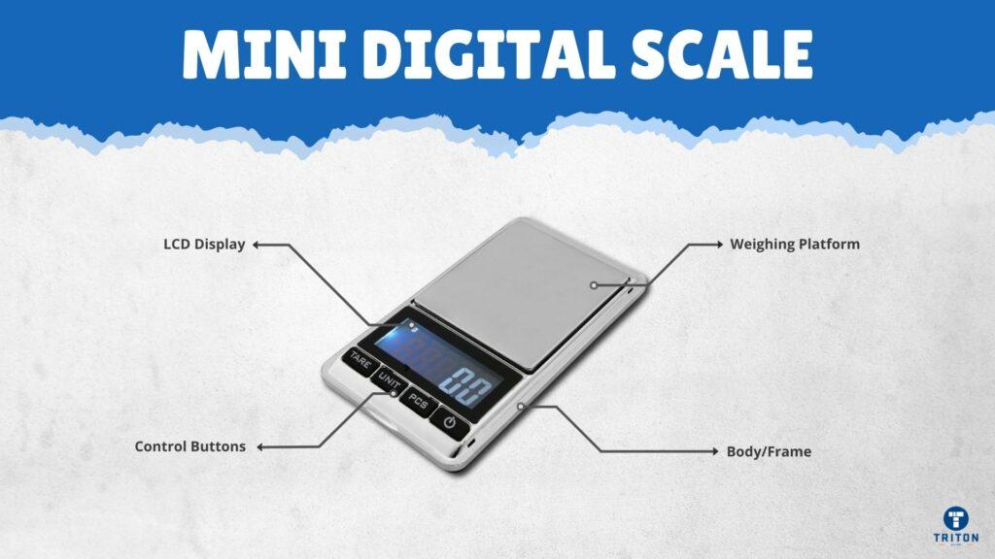
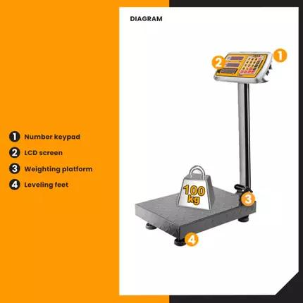
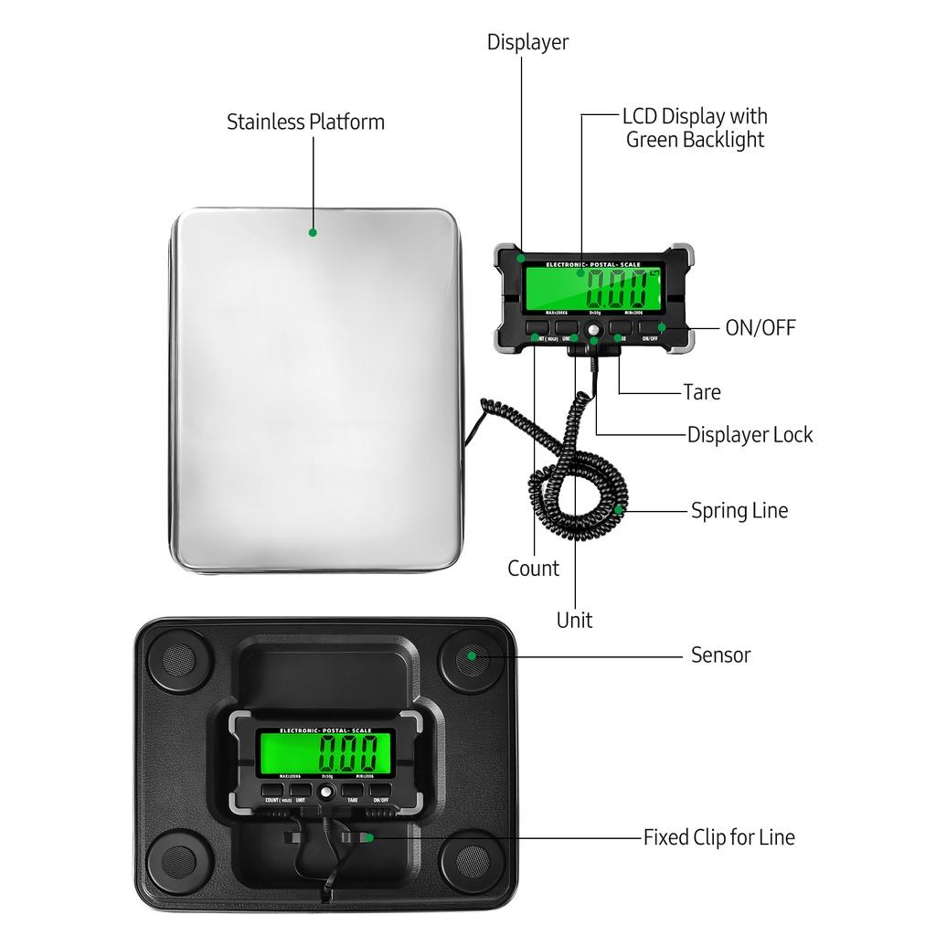
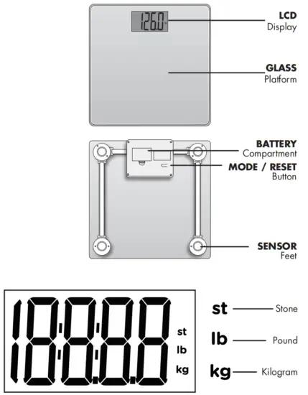
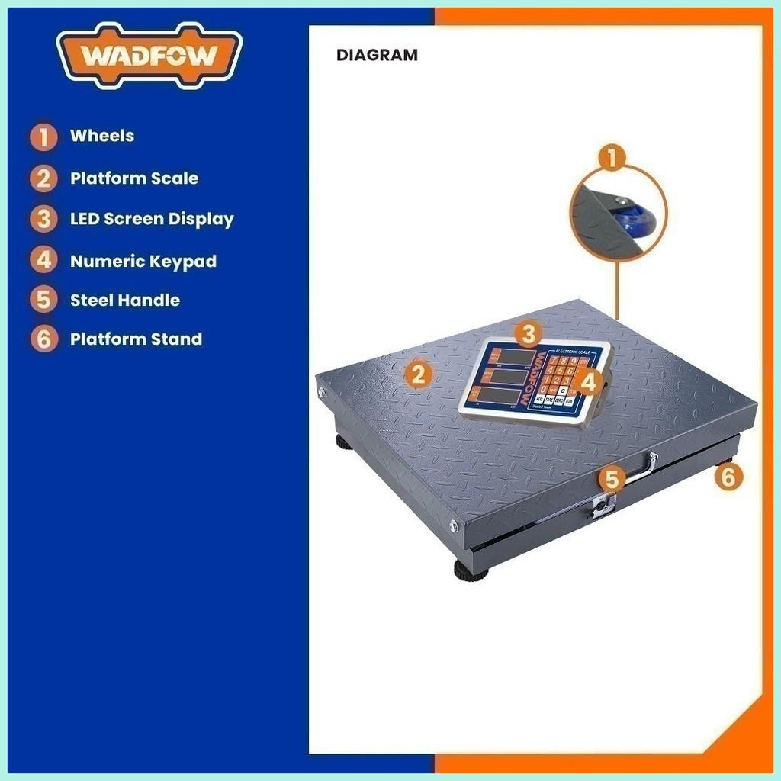
A typical weighing scale consists of:
- Weighing platform
- Load cell or spring mechanism
- Display (analog or digital)
- Control buttons
- Base/frame
- Power source (battery or mains, for electronic models)

Types of Weighing Scales

1. Mechanical Weighing Scale
# Source: AI Source: Provided by: [Data Path: Persons Table -> ID Column: 1, Name_En Column: Motasem Essam] -> From: [ChatGPT] on [7/17/2026]
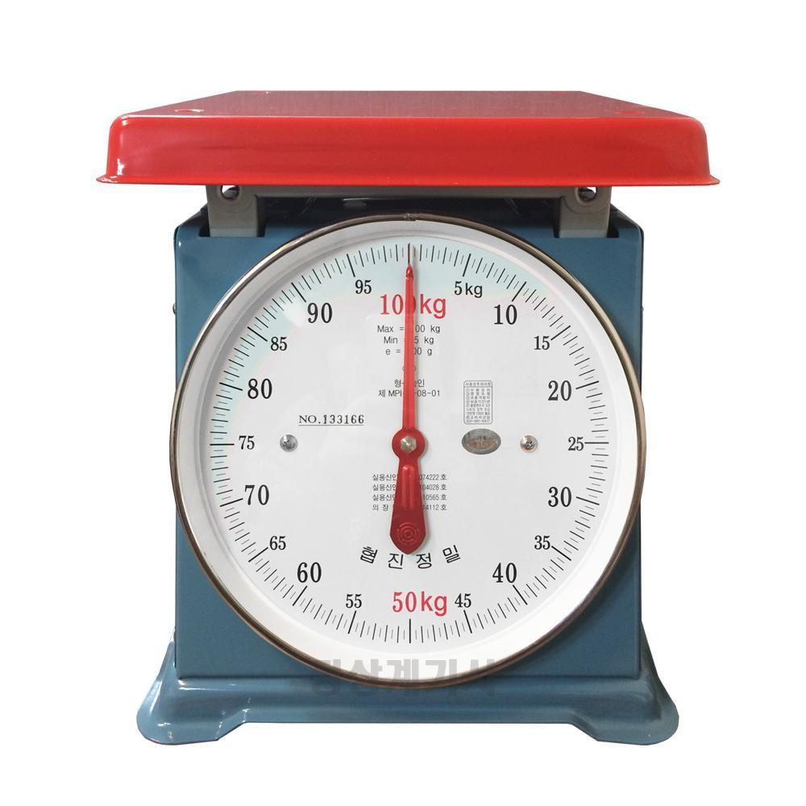
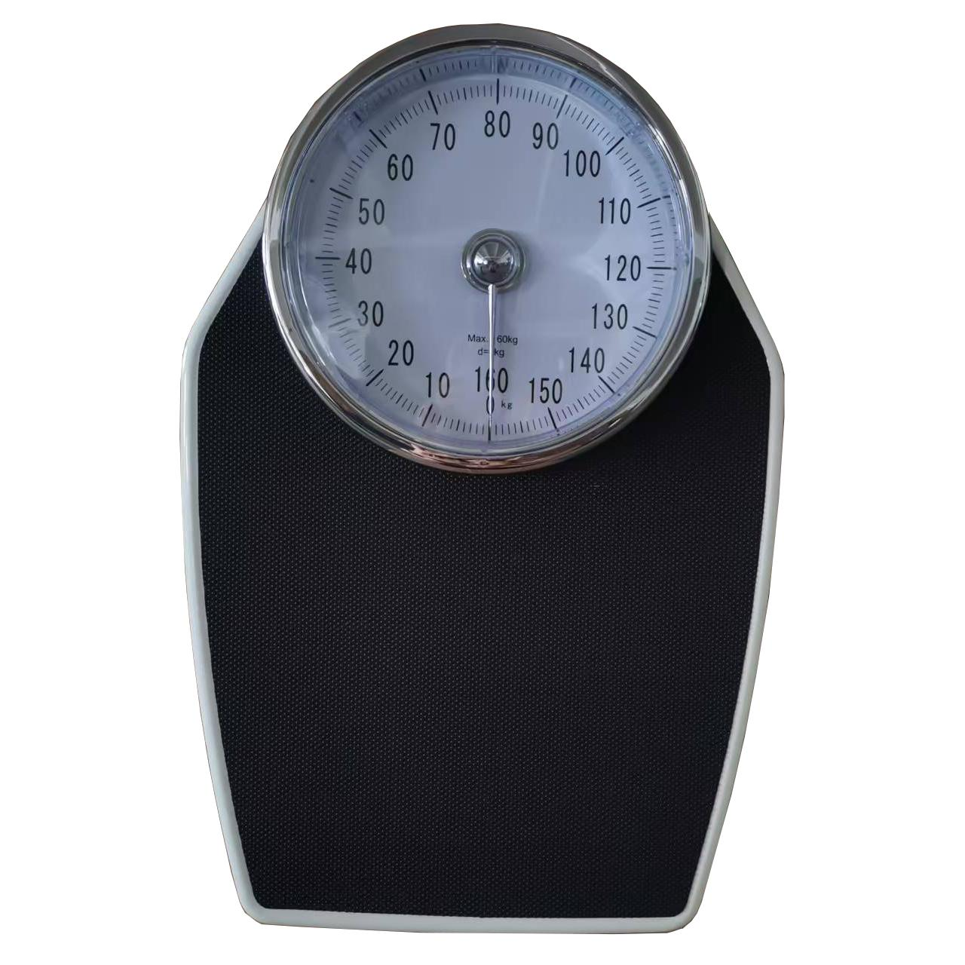
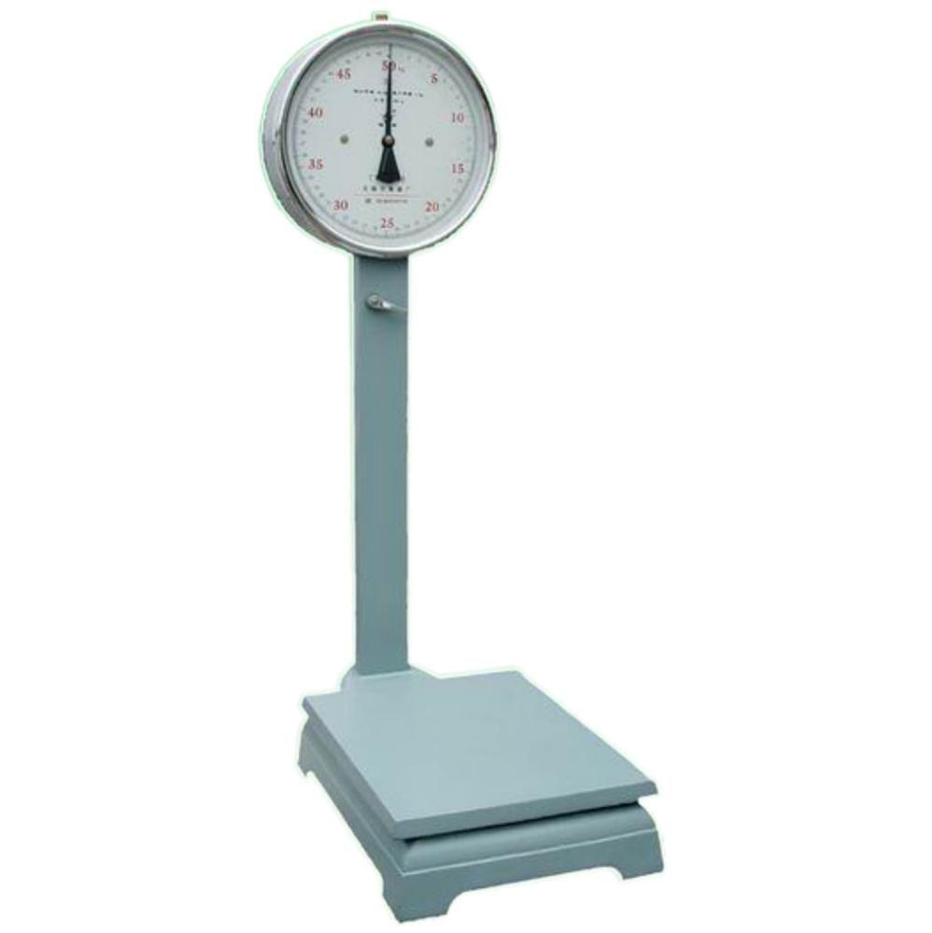
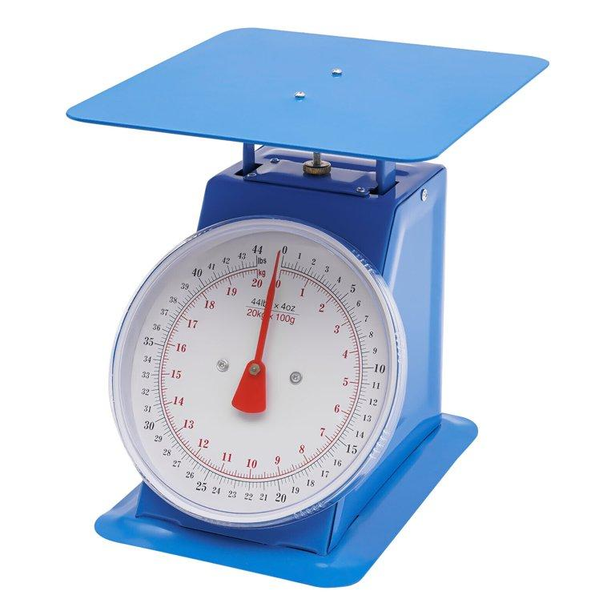
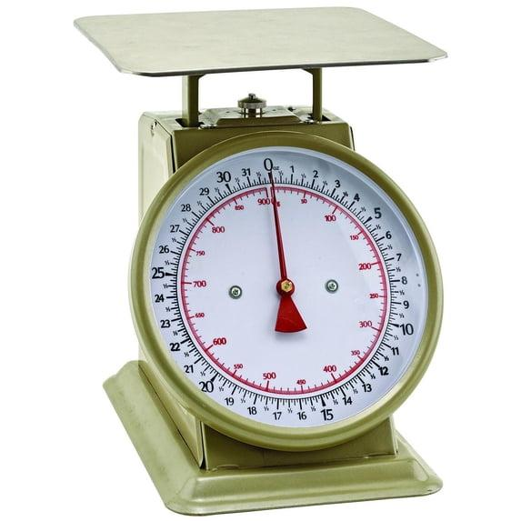
Description
Uses a spring mechanism to measure weight.
Features
- No batteries
- Analog dial
- Simple construction
Applications
- Homes
- Schools
- Basic weighing tasks

2. Digital Weighing Scale
# Source: AI Source: Provided by: [Data Path: Persons Table -> ID Column: 1, Name_En Column: Motasem Essam] -> From: [ChatGPT] on [7/17/2026]
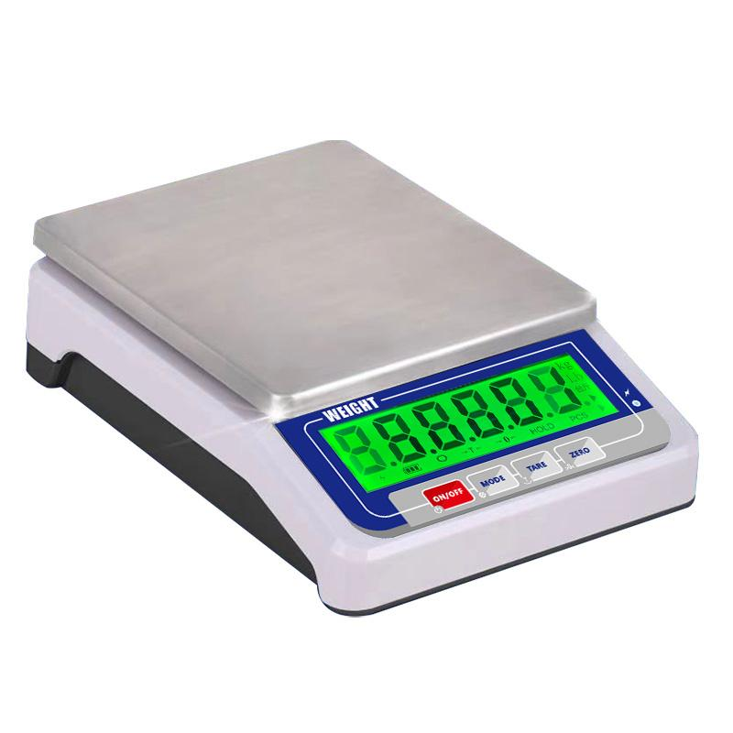
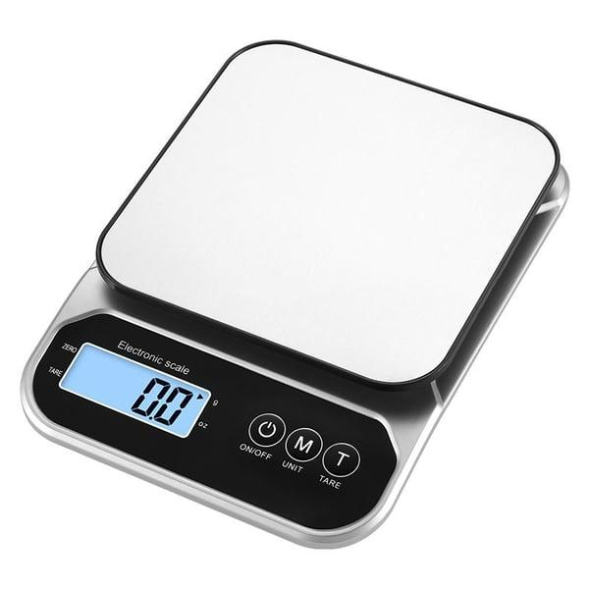
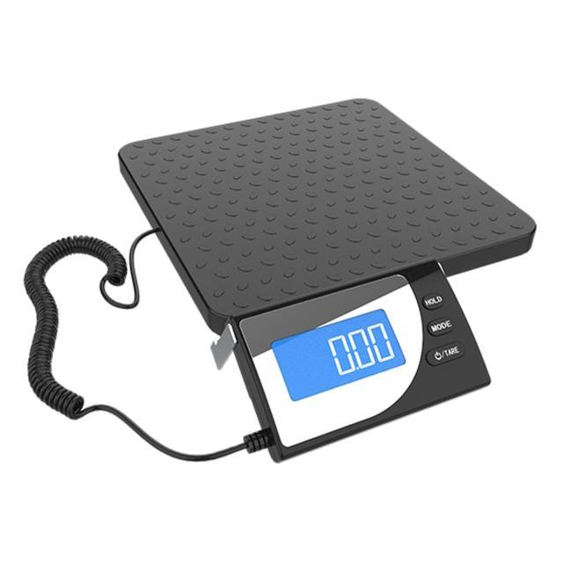
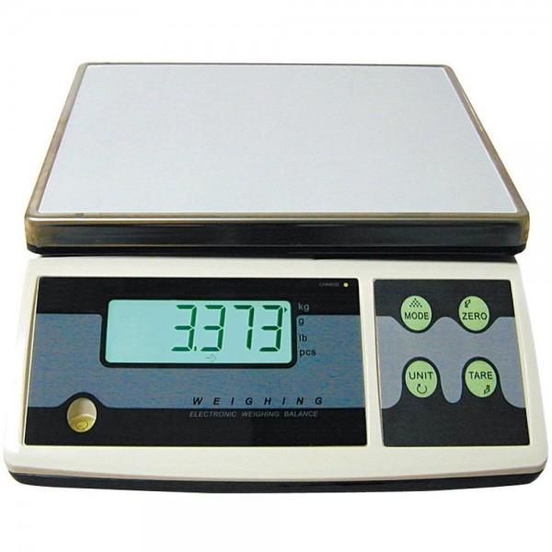
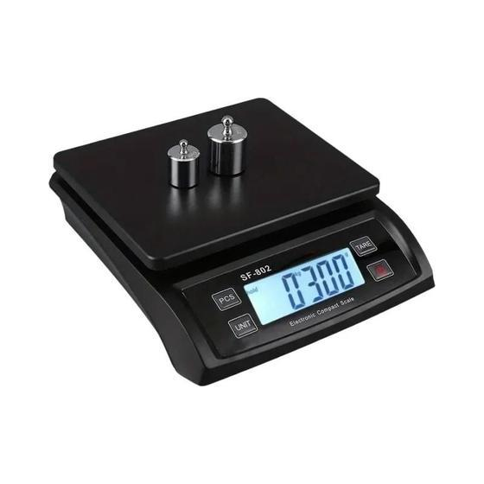
Description
Uses electronic load cells to provide accurate digital readings.
Features
- LCD display
- High precision
- Tare function
- Multiple units
Applications
- Homes
- Retail
- Laboratories
- Offices

3. Platform Weighing Scale
# Source: AI Source: Provided by: [Data Path: Persons Table -> ID Column: 1, Name_En Column: Motasem Essam] -> From: [ChatGPT] on [7/17/2026]
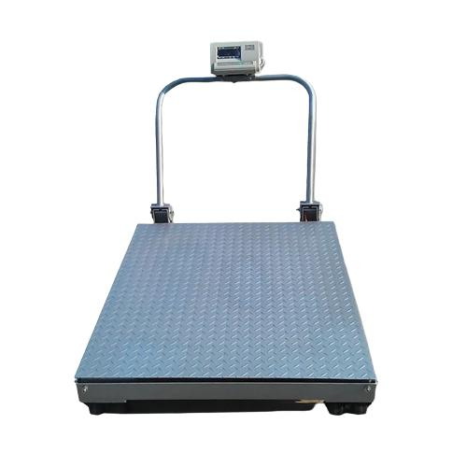
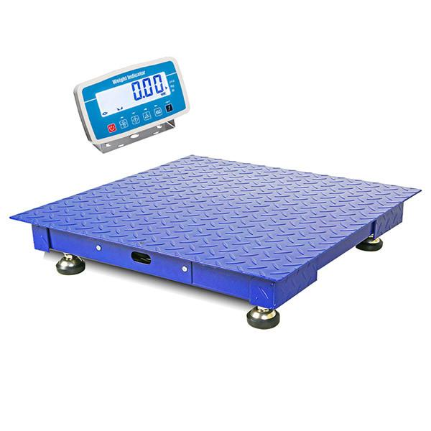
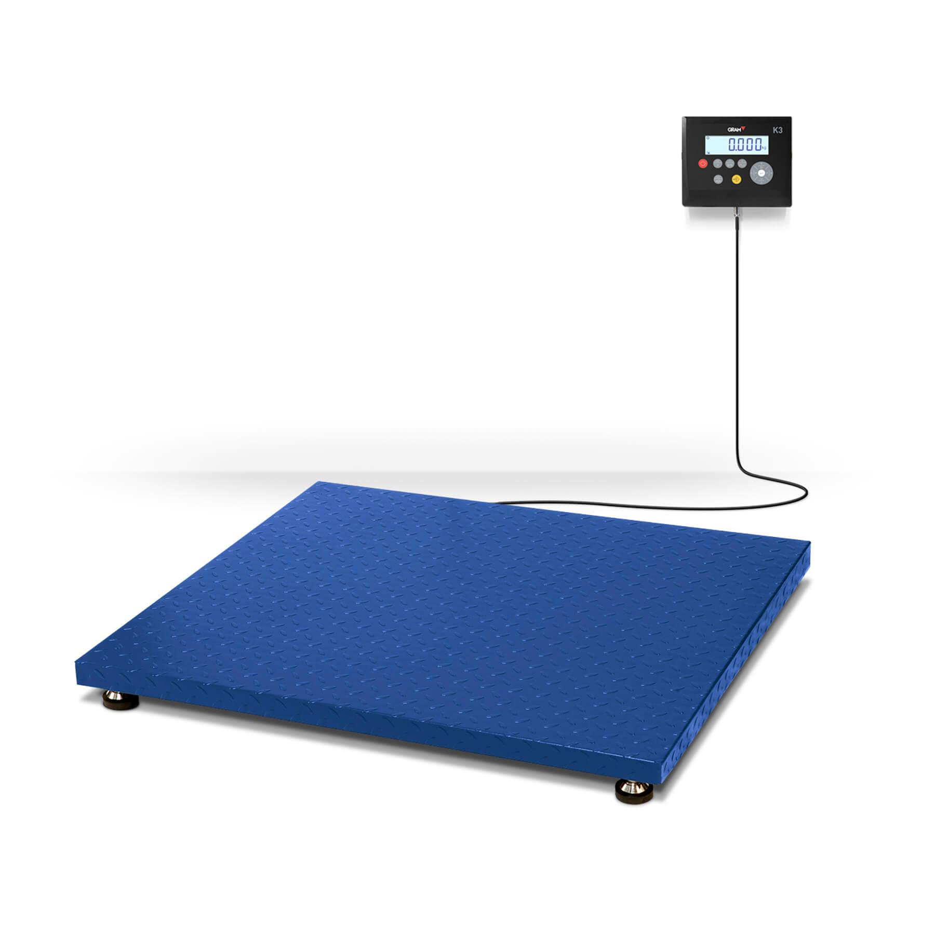
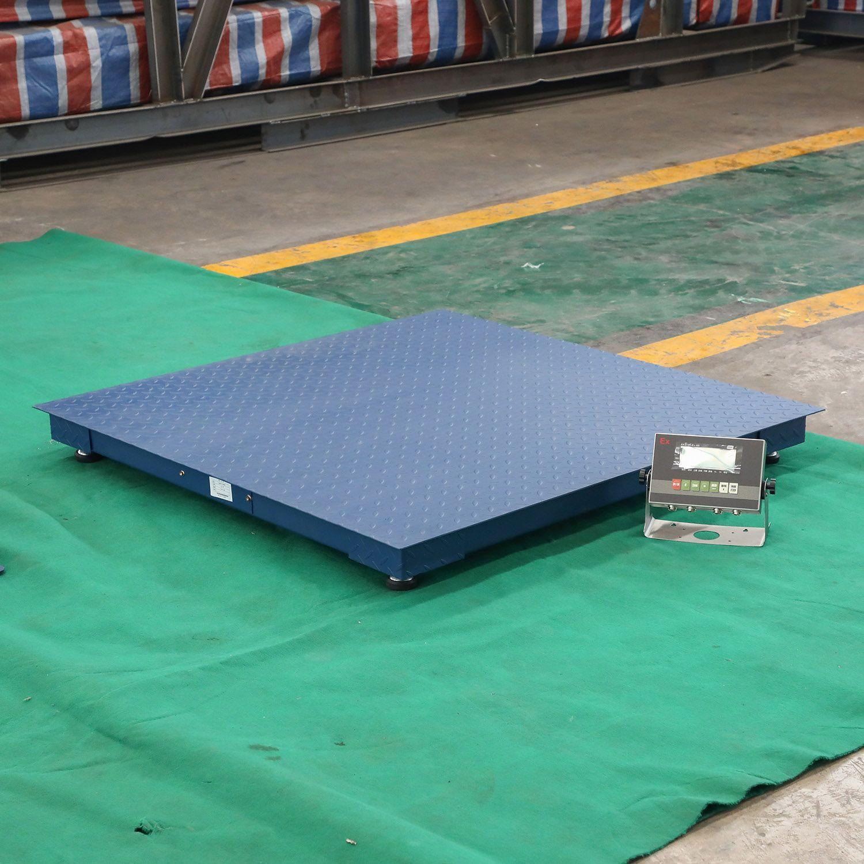
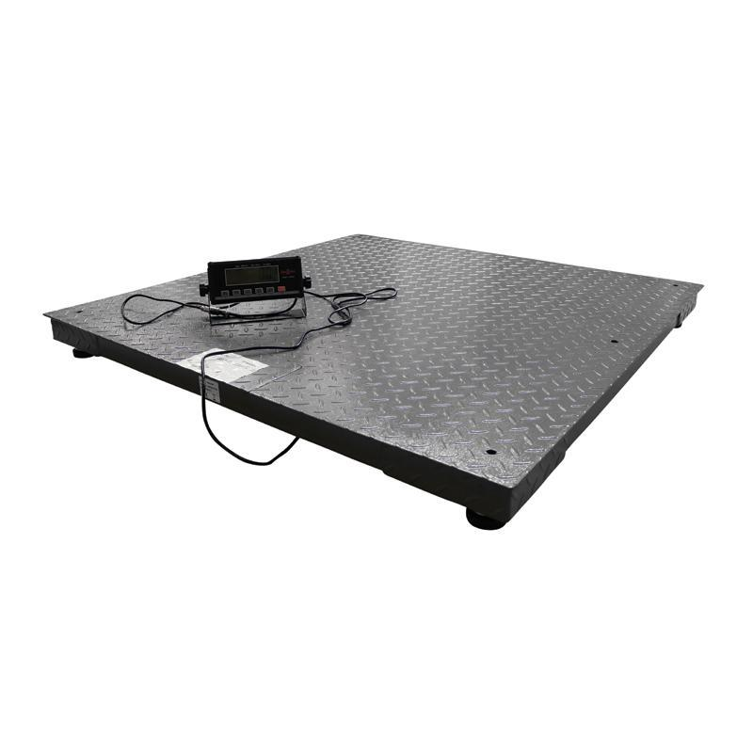
Description
A heavy-duty scale with a large platform for weighing bulky or heavy objects.
Applications
- Warehouses
- Factories
- Shipping
- Logistics

4. Hanging Weighing Scale
# Source: AI Source: Provided by: [Data Path: Persons Table -> ID Column: 1, Name_En Column: Motasem Essam] -> From: [ChatGPT] on [7/17/2026]
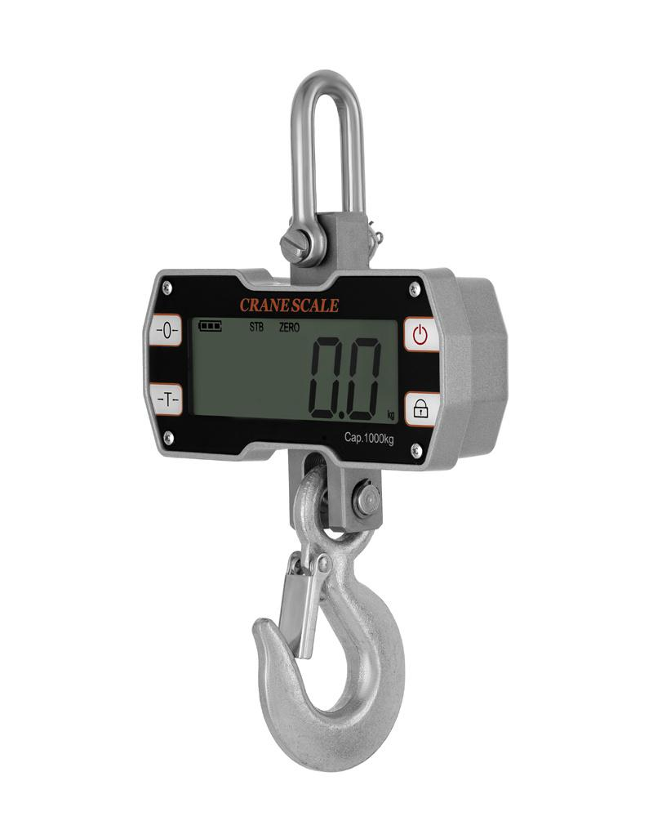
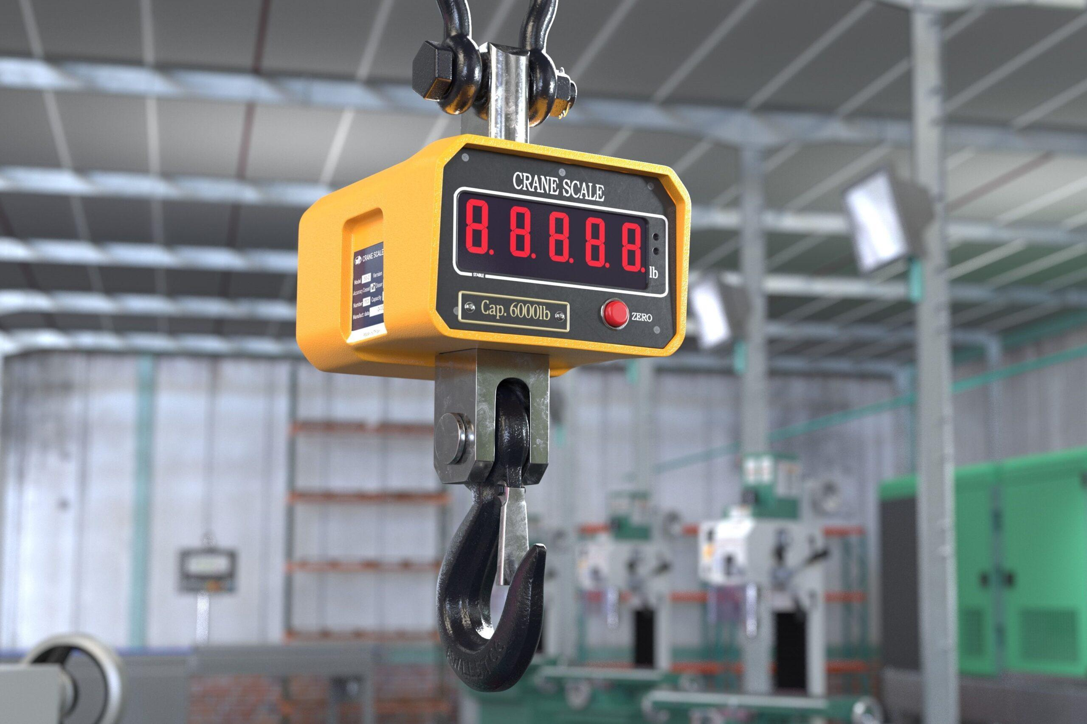
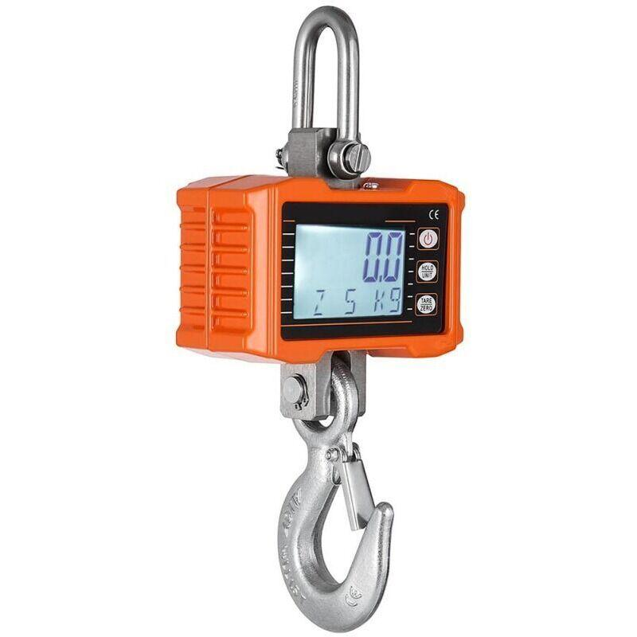
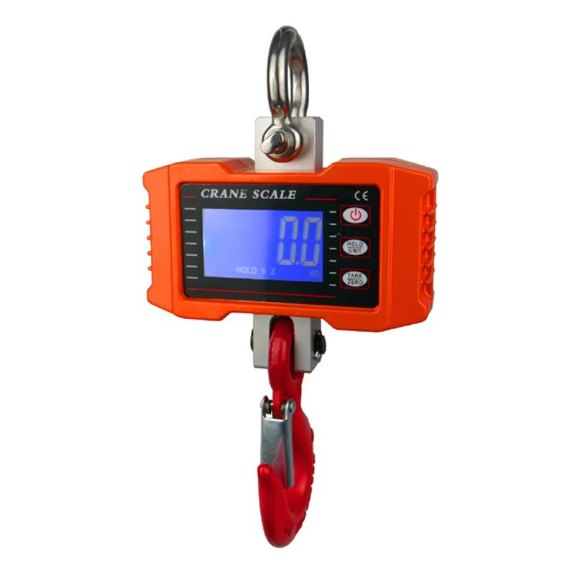
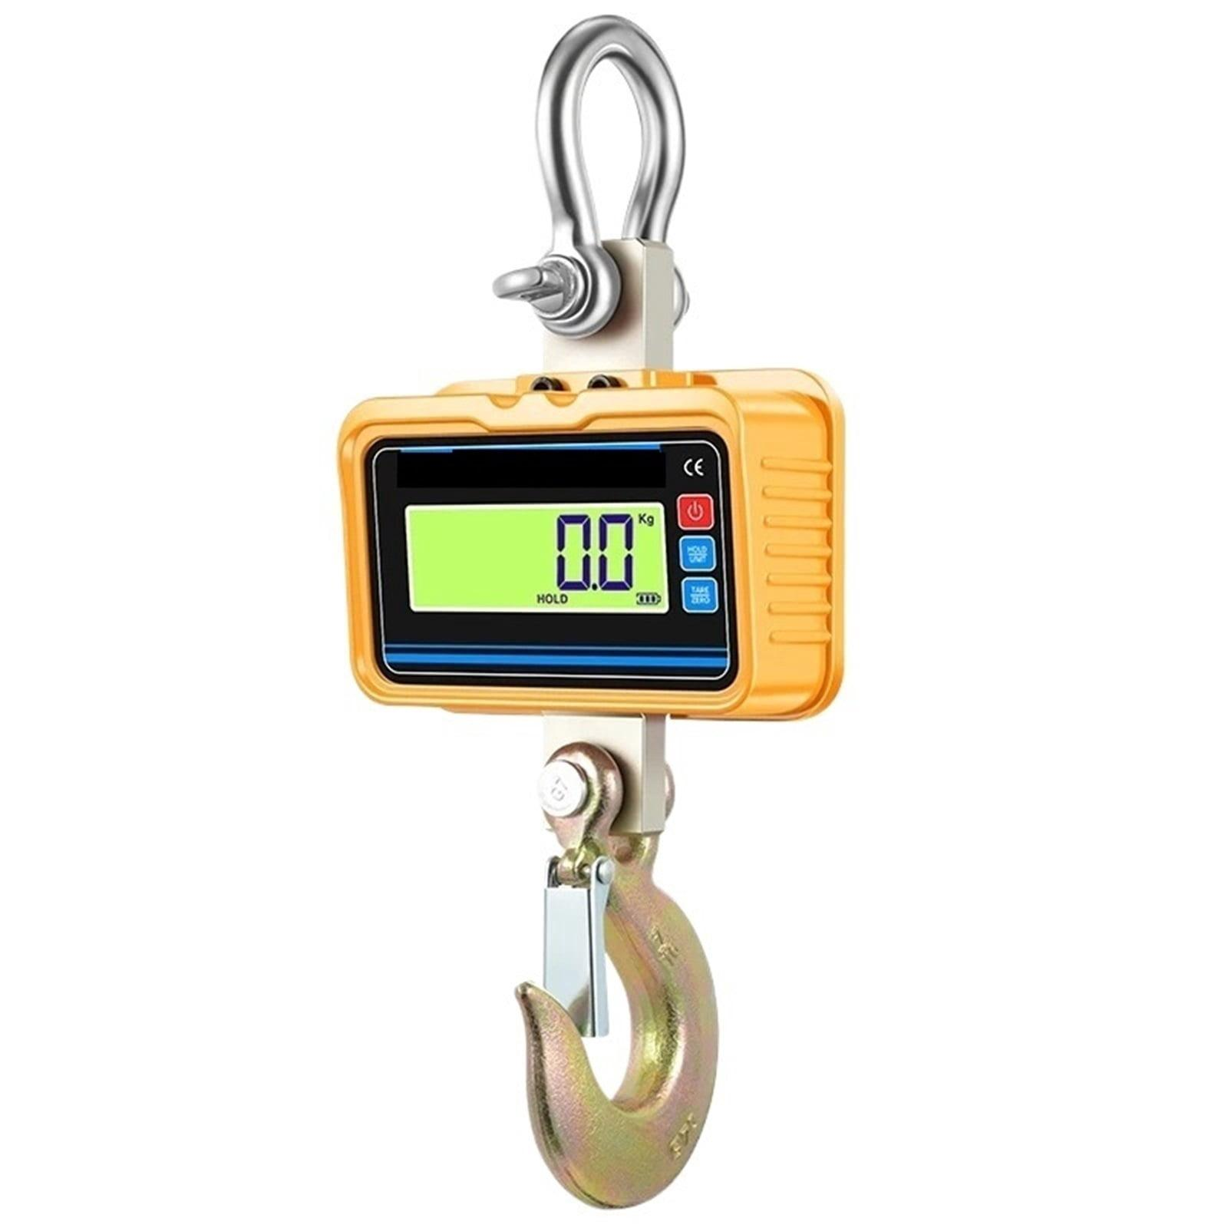
Description
Measures the weight of suspended loads using a hook.
Applications
- Fishing
- Agriculture
- Construction
- Warehouses

5. Bathroom Scale
# Source: AI Source: Provided by: [Data Path: Persons Table -> ID Column: 1, Name_En Column: Motasem Essam] -> From: [ChatGPT] on [7/17/2026]
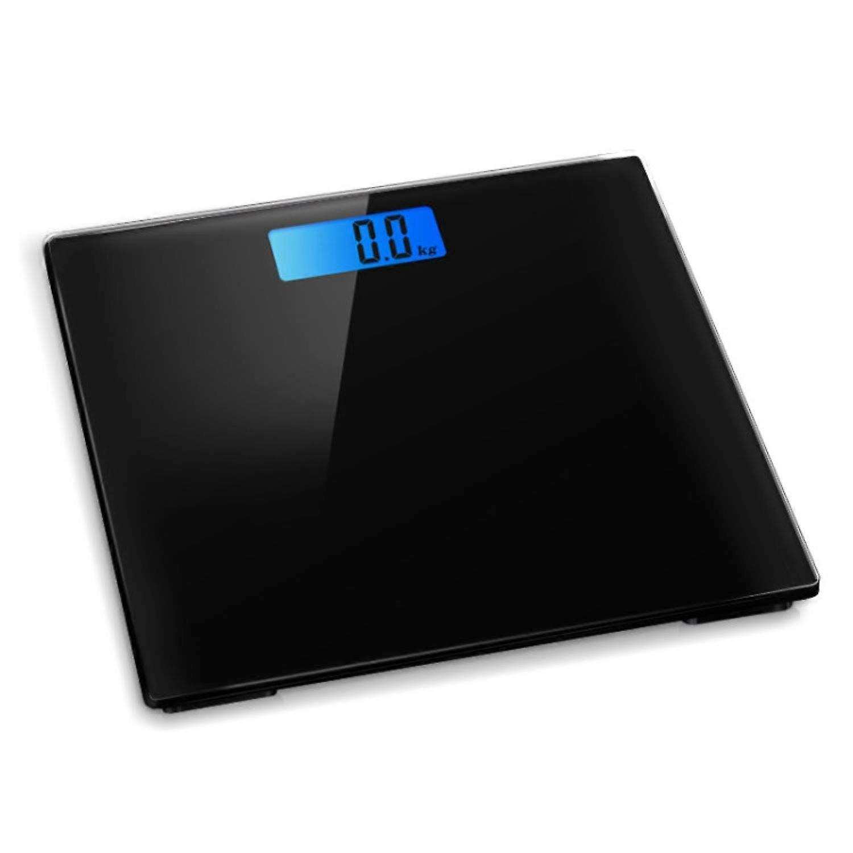
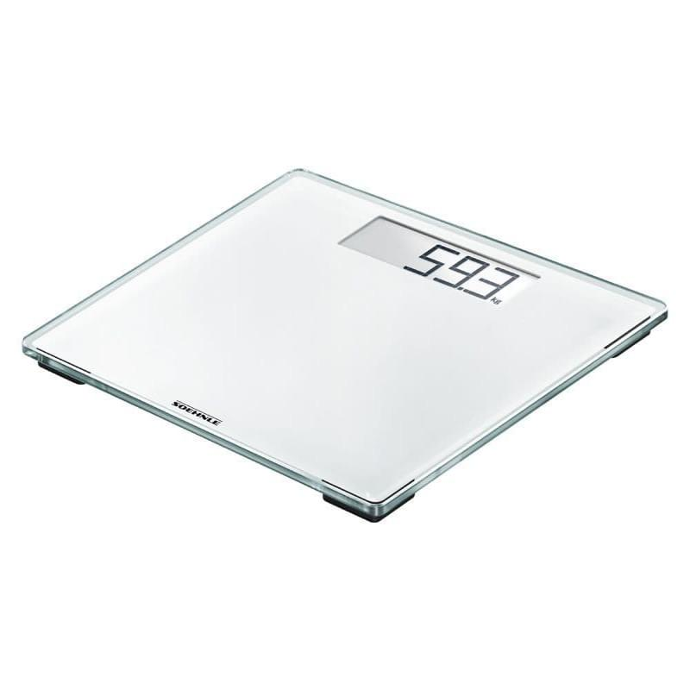
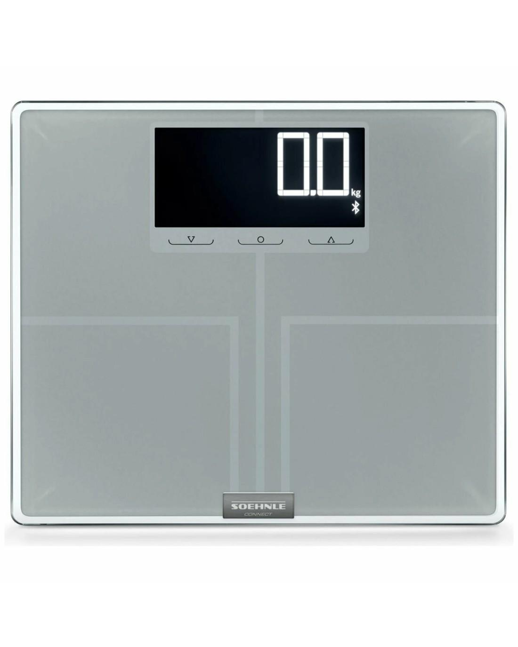
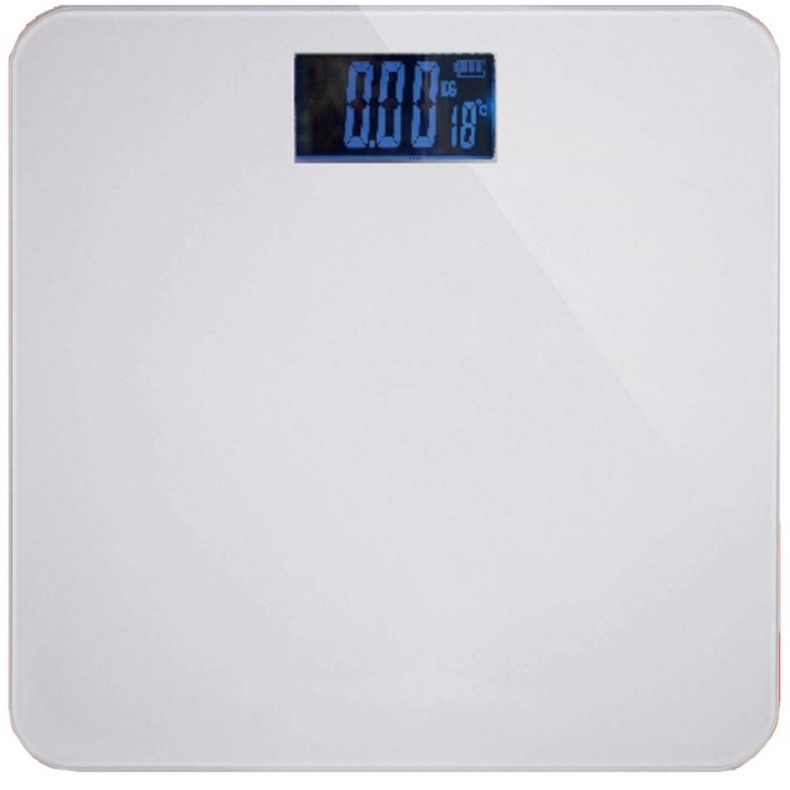
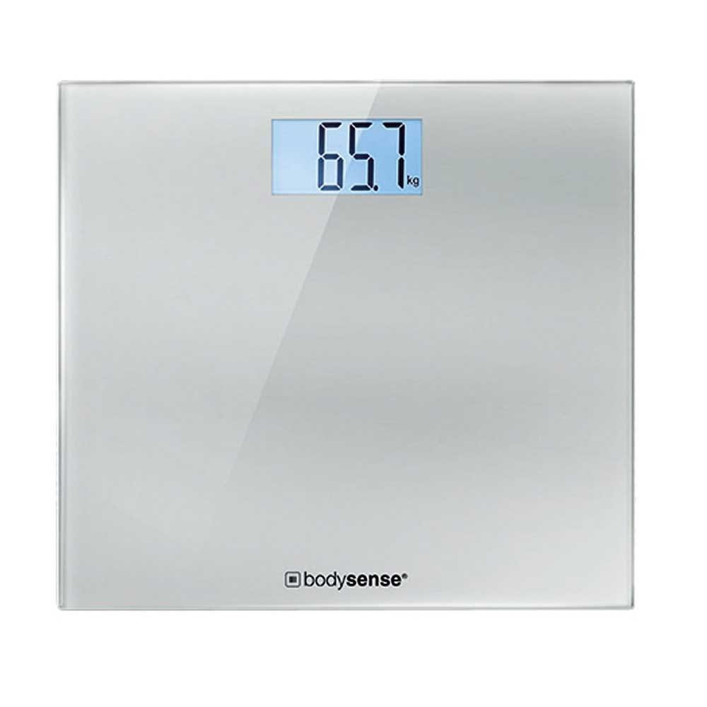
Description
Designed specifically for measuring body weight.
Applications
- Homes
- Clinics
- Fitness centers

6. Kitchen Scale
# Source: AI Source: Provided by: [Data Path: Persons Table -> ID Column: 1, Name_En Column: Motasem Essam] -> From: [ChatGPT] on [7/17/2026]
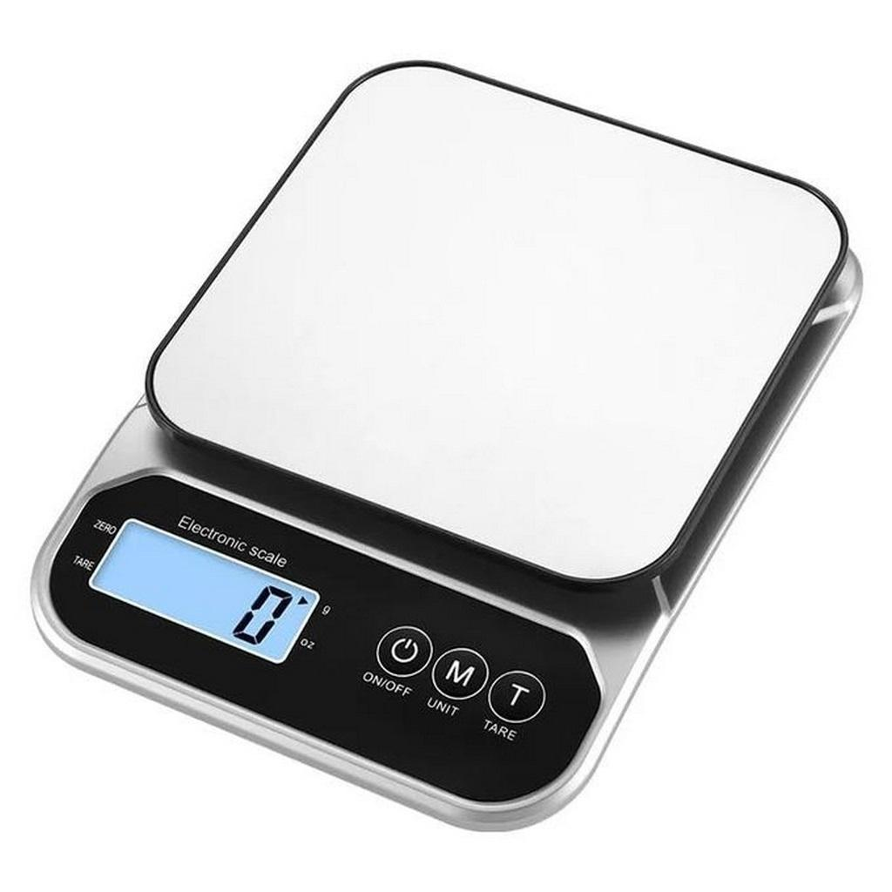
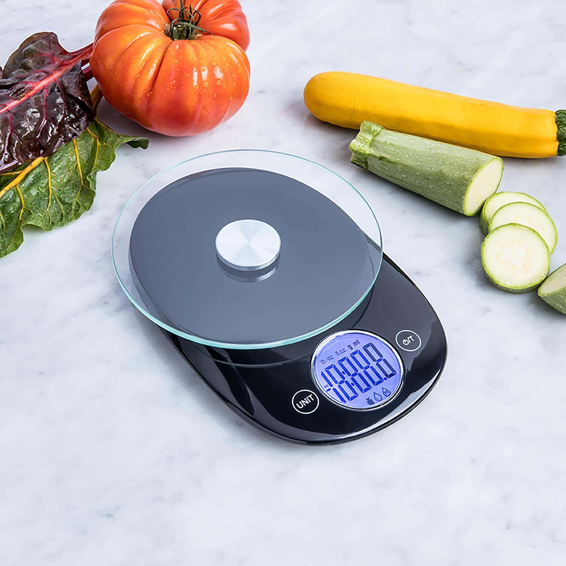
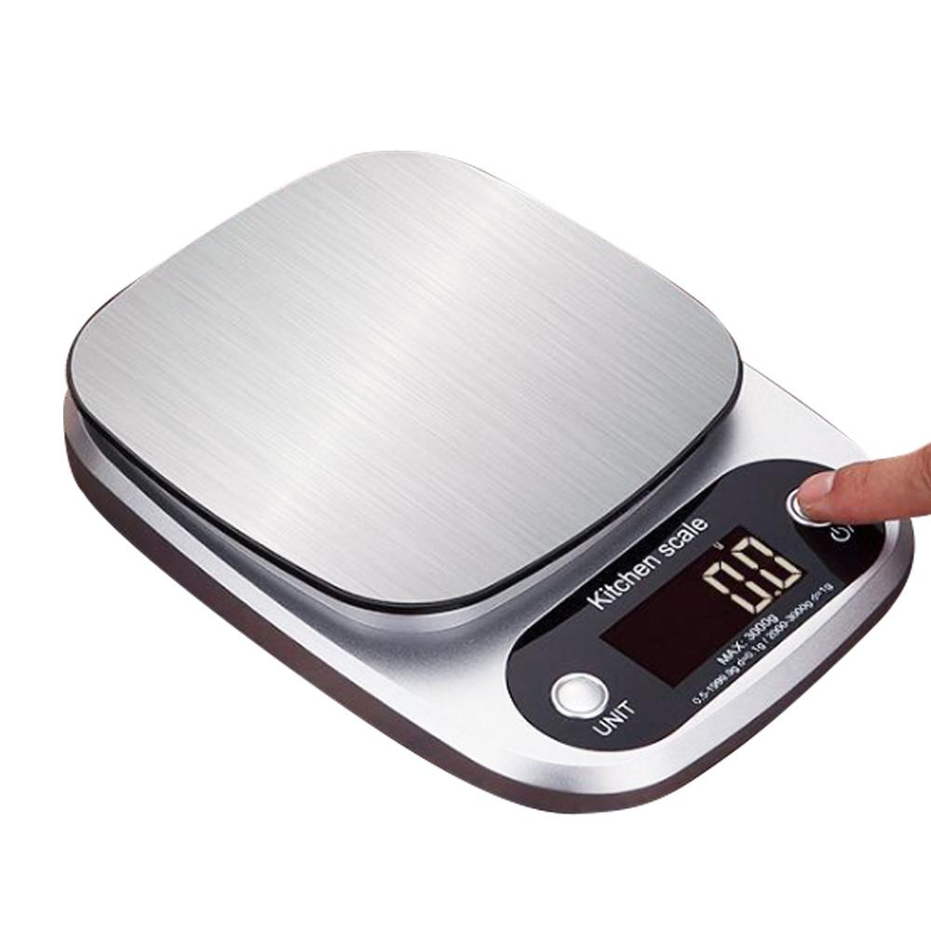
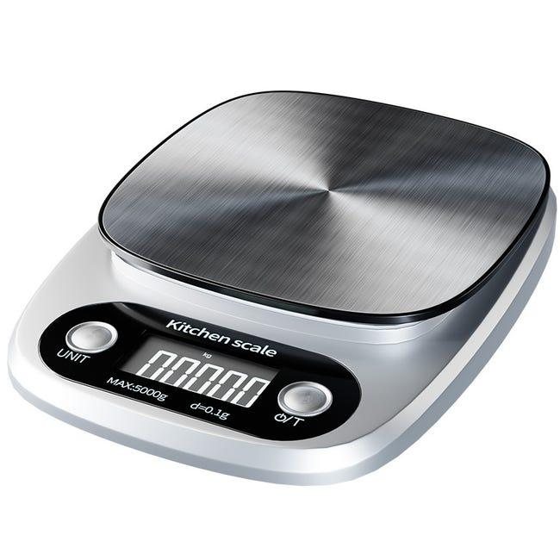
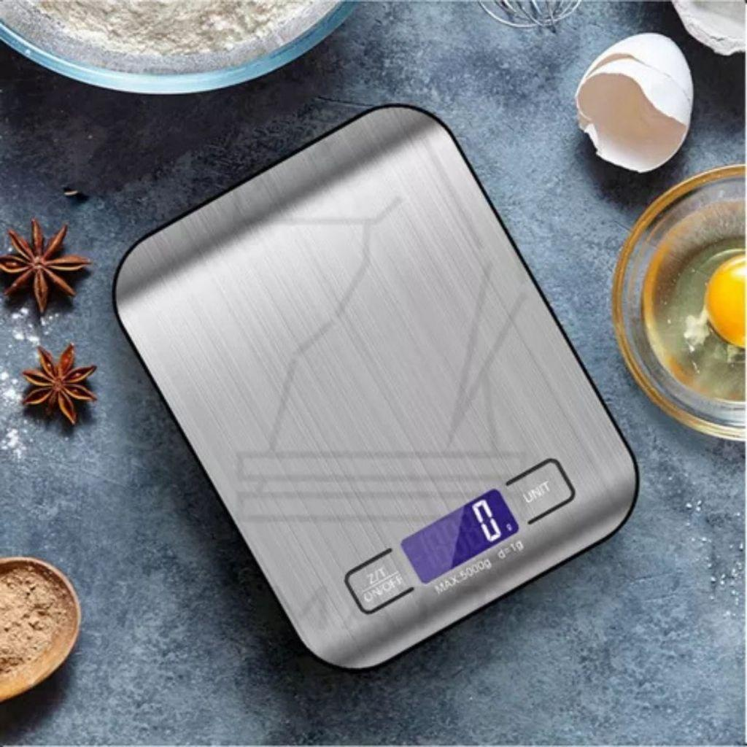
Description
Designed for measuring food ingredients with high precision.
Applications
- Cooking
- Baking
- Food preparation

Measuring Units
# Source: AI Source: Provided by: [Data Path: Persons Table -> ID Column: 1, Name_En Column: Motasem Essam] -> From: [ChatGPT] on [7/17/2026]
Weighing scales commonly display:
- Kilogram (kg)
- Gram (g)
- Pound (lb)
- Ounce (oz)

Measuring Range
# Source: AI Source: Provided by: [Data Path: Persons Table -> ID Column: 1, Name_En Column: Motasem Essam] -> From: [ChatGPT] on [7/17/2026]
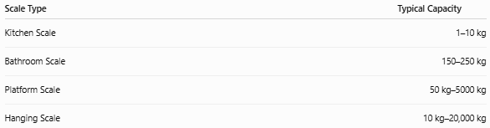
Scale Type | Typical Capacity
Kitchen Scale | 1–10 kg
Bathroom Scale | 150–250 kg
Platform Scale | 50 kg–5000 kg
Hanging Scale | 10 kg–20,000 kg

Resolution
# Source: AI Source: Provided by: [Data Path: Persons Table -> ID Column: 1, Name_En Column: Motasem Essam] -> From: [ChatGPT] on [7/17/2026]
Typical resolutions:
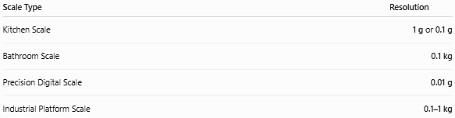
Scale Type | Resolution
Kitchen Scale | 1 g or 0.1 g
Bathroom Scale | 0.1 kg
Precision Digital Scale | 0.01 g
Industrial Platform Scale | 0.1–1 kg

How to Use a Weighing Scale
# Source: AI Source: Provided by: [Data Path: Persons Table -> ID Column: 1, Name_En Column: Motasem Essam] -> From: [ChatGPT] on [7/17/2026]
- Place the scale on a stable, level surface.
- Turn it on (digital models).
- Wait until it reads zero.
- Place the object on the platform (or hang it from the hook).
- Wait for the reading to stabilize.
- Record the displayed value.

Example
# Source: AI Source: Provided by: [Data Path: Persons Table -> ID Column: 1, Name_En Column: Motasem Essam] -> From: [ChatGPT] on [7/17/2026]
Suppose the display shows:
12.75 kg
The measured value is:
- 12.75 kg
- 12,750 g
- 28.11 lb (approximately)

Accuracy
# Source: AI Source: Provided by: [Data Path: Persons Table -> ID Column: 1, Name_En Column: Motasem Essam] -> From: [ChatGPT] on [7/17/2026]
Typical accuracy depends on:
- Scale quality
- Load cell design
- Calibration
- Environmental conditions
Higher-quality electronic scales generally provide better accuracy than simple mechanical scales.

Sources of Error
# Source: AI Source: Provided by: [Data Path: Persons Table -> ID Column: 1, Name_En Column: Motasem Essam] -> From: [ChatGPT] on [7/17/2026]
Instrument Errors
- Calibration drift
- Damaged load cell
- Worn spring (mechanical scales)
- Low battery (digital models)

Observation Errors
- Reading before stabilization
- Incorrect unit selection

Positioning Errors
- Uneven surface
- Off-center loading
- Overloading

Environmental Errors
- Vibration
- Temperature changes
- Dust
- Moisture

Applications
# Source: AI Source: Provided by: [Data Path: Persons Table -> ID Column: 1, Name_En Column: Motasem Essam] -> From: [ChatGPT] on [7/17/2026]
Weighing scales are used in:
- Homes
- Hospitals
- Retail stores
- Supermarkets
- Laboratories
- Warehouses
- Manufacturing
- Agriculture
- Shipping and logistics
- Food industry

Advantages
# Source: AI Source: Provided by: [Data Path: Persons Table -> ID Column: 1, Name_En Column: Motasem Essam] -> From: [ChatGPT] on [7/17/2026]
A weighing scale:
- Provides quick measurements.
- Is easy to operate.
- Is available in many capacities.
- Offers digital displays and tare functions (electronic models).
- Can measure very small or very large loads, depending on the type.

Limitations
# Source: AI Source: Provided by: [Data Path: Persons Table -> ID Column: 1, Name_En Column: Motasem Essam] -> From: [ChatGPT] on [7/17/2026]
A weighing scale:
- Measures weight (force) directly; the displayed mass assumes standard gravitational conditions.
- Requires periodic calibration.
- Electronic models require batteries or electrical power.
- Precision decreases if overloaded or improperly used.

Comparison with Other Mass and Weight Measuring Instruments
# Source: AI Source: Provided by: [Data Path: Persons Table -> ID Column: 1, Name_En Column: Motasem Essam] -> From: [ChatGPT] on [7/17/2026]
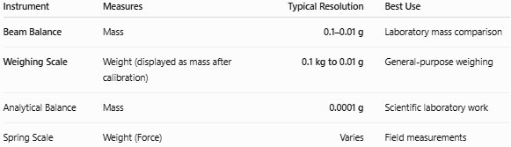
Instrument | Measures | Typical Resolution | Best Use
Beam Balance | Mass | 0.1–0.01 g | Laboratory mass comparison
Weighing Scale | Weight (displayed as mass after calibration) | 0.1 kg to 0.01 g | General-purpose weighing
Analytical Balance | Mass | 0.0001 g | Scientific laboratory work
Spring Scale | Weight (Force) | Varies | Field measurements

Care and Maintenance
# Source: AI Source: Provided by: [Data Path: Persons Table -> ID Column: 1, Name_En Column: Motasem Essam] -> From: [ChatGPT] on [7/17/2026]
To maintain accuracy:
- Keep the platform clean.
- Place the scale on a level surface.
- Avoid overloading.
- Calibrate periodically.
- Replace batteries when necessary.
- Protect from moisture and impacts.

Common Mistakes
# Source: AI Source: Provided by: [Data Path: Persons Table -> ID Column: 1, Name_En Column: Motasem Essam] -> From: [ChatGPT] on [7/17/2026]
- Confusing weight with mass.
- Using the scale on an uneven surface.
- Exceeding the maximum capacity.
- Not zeroing (taring) the scale before weighing.
- Reading the display before it stabilizes.

Key Points
# Source: AI Source: Provided by: [Data Path: Persons Table -> ID Column: 1, Name_En Column: Motasem Essam] -> From: [ChatGPT] on [7/17/2026]
- A Weighing Scale measures the force due to gravity (weight) and commonly displays the result as mass.
- Common types include:
  - Mechanical Weighing Scale
  - Digital Weighing Scale
  - Platform Scale
  - Hanging Scale
  - Bathroom Scale
  - Kitchen Scale
- Typical resolutions range from 0.1 kg for bathroom scales to 0.01 g for precision digital scales.
- Used extensively in homes, commerce, laboratories, manufacturing, healthcare, and logistics.

Conclusion
# Source: AI Source: Provided by: [Data Path: Persons Table -> ID Column: 1, Name_En Column: Motasem Essam] -> From: [ChatGPT] on [7/17/2026]
A Weighing Scale is one of the most widely used measuring instruments for determining the weight of objects, with most modern devices displaying the equivalent mass in units such as kilograms or grams. Available in mechanical and digital forms and in capacities ranging from small kitchen scales to heavy industrial platform scales, weighing scales play an essential role in daily life, healthcare, commerce, manufacturing, transportation, and scientific work. Proper calibration, correct usage, and regular maintenance are essential to ensure reliable and accurate measurements.

